|  |  |
| --- | --- |
| **Subject: Anatomy (2)** | **Year 2019 /2020** |
| **first year** | **2st Term Exam** |
| **Total Marks: 60** | **Date : 12 / 7/2020** |
| **Dr/ELSYED ELHADY** | **Time allowed: 2hours** |

**ALL Questions should be answered**

**1-What are the contents of the biliary system? (4 marks)**

**2- Enumerate the contents of the middle Ear? (6 marks)**

**3- complete the following table? ( 8 marks)**

|  |  |
| --- | --- |
| **Type of Fibers.** | **Cr. N.** |
| **……….** | **Olfactory** |
| **…………** | **Optic** |
| **motor**  **parasymp.** | **Oculomotor** |
| **…………** | **Troclear** |
| **mixed** | **Trigeminal** |
| **…………..** | **Abducent** |
| **…………..** | **Facial** |
| **…………..** | **Vestibulocochlear** |
| **mixed** | **Glossopharyngeal** |
| **…………….** | **Vagus** |
| **motor** | **Accessory** |
| **……………** | **Hypoglossal** |

**4- Give short account on vascular Coat of the eye? (6 marks)**

**5-** **Complete the following table using the figure? (6 marks)**

|  |  |  |  |  |  |
| --- | --- | --- | --- | --- | --- |
| **a** | **b** | **c** | **d** | **e** | **f** |
|  |  |  |  |  |  |

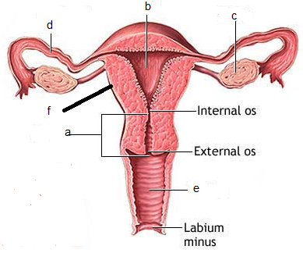

**6-State true or false (15 marks)** **1-The spinal cord occupies the upper 2/3 of vertebral canal**

**2-The cranial Nerves are 11 pairs in number.**

**3-The pituitary gland is regulated by thyroid gland.**

**4- The thyroid gland lies in the lower part of the neck.**

**5- The *ext*ernal acoustic meatus is 3 inches in length. Its lateral third is cartilaginous, while the medial two-thirds are bony.**

**6- The cystic duct is 1.5 inches (4 cm) long, it is usually V-shaped.**

**7- The ejaculatory ducts are formed by union of vas deferens with duct of seminal vesicle on each side.**

**8- The sclera is formed of dense black elastic tissue**

**9-The iris is a circular diaphragm anterior to the cornea. It presents a central hole called the *pupil.***

**10- The common bile duct is formed by the union of the cystic duct and common hepatic duct**

|  |  |  |  |  |  |  |  |  |  |
| --- | --- | --- | --- | --- | --- | --- | --- | --- | --- |
| 1 | 2 | 3 | 4 | 5 | 6 | 7 | 8 | 9 | 10 |
|  |  |  |  |  |  |  |  |  |  |

8**-CROSS MATCHING** **(15 marks)**

|  |  |  |  |
| --- | --- | --- | --- |
|  | **A** |  | **B** |
| **1** | **Lens** | **a** | ***connects the right atrium with the right ventricle*** |
| **2** | ***Vagus*** | **b** | **above the kidneys** |
| **3** | **Suprarenal** | **c** | **Lies in front of lower part of the neck** |
| **4** | **Endometrium** | **d** | **Mixed gland** |
| **5** | **Tricuspid valve** | **e** | **It is a transparent, solid, elastic & biconvex.** |
| **6** | **Vagina** | **f** | **It shed out during menstruation.** |
| **7** | **Choroid** | **g** | **located between the urinary bladder & the rectum.** |
| **8** | **Clitoris** | **h** | ***Cranial nerve*** |
| **9** | **Thyroid gland** | **i** | **Female vulva** |
| **10** | **pancreas** | **j** | ***lying between the sclera & retina*** |

|  |  |  |  |  |  |  |  |  |  |
| --- | --- | --- | --- | --- | --- | --- | --- | --- | --- |
| 1- | 2- | 3- | 4- | 5- | 6- | 7- | 8- | 9- | 10- |

**Good Luck**