|  |  |
| --- | --- |
| **Subject: Physiology1 Med121** | **Year 2020-2021** |
| **Level 1** | **First term** |
| **Total Marks: 50** | **Date: 7 /3/2021** |
| **Assistant prof. Dr. Mona A. Hussain** | **Time Allowed: Two Hours** |

**Answer all the following questions: (10 marks for each one)**

1. Define anemia and mention its causes.

**Anemia is defined as a decrease in the ability of the blood to carry oxygen due to**

**(1) a decrease in the total number of erythrocytes, each having a normal quantity of hemoglobin,**

**(2) a diminished concentration of hemoglobin per erythrocyte, or**

**(3) a combination of both**

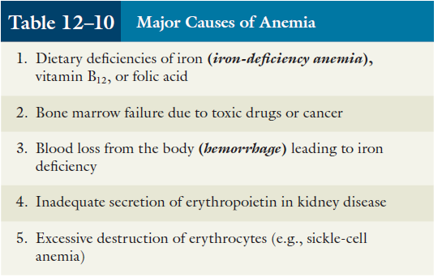

1. Discuss plasma proteins (concentration, types, site of synthesis and functions).

**Proteins concentration: 6.5 – 8 g/ dl**

**Classified into:**

**1- Albumin**

**2- Globulins**

**3- Fibrinogen**

**Site of synthesis: The liver Except gamma globulins by immune cells**

**Bind and transport other plasma constituents**

**PH puffer**

**Immunity ( gamma globulins)**

**Blood viscosity ( fibrinogen)**

**Blood clotting ( fibrinogens and other clotting factors**

**Osmotic pressure ( albumins)**

**Nutrients in starvation**

1. Compare between autonomic and somatic nervous system.



1. Compare between innate immunity and adaptive immunity.

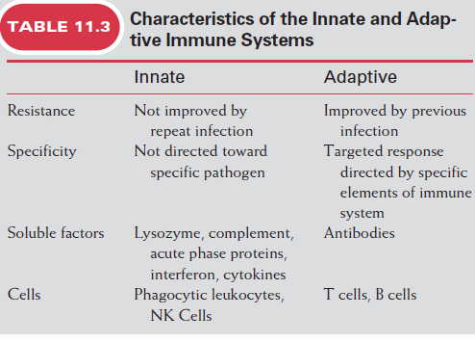

1. Discuss body fluid compartments (volume and composition).

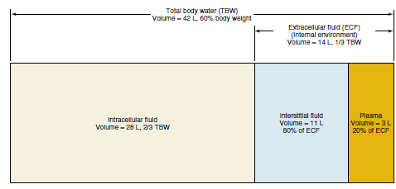

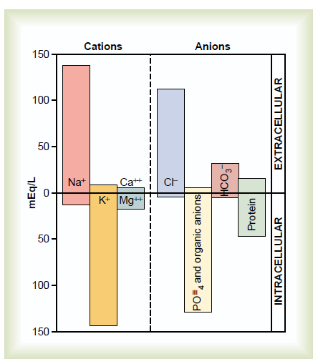

**The end of questions& Good Luck**

**Mona A Hussain**